**Assignment 1 – Experiential Learning & Case Study**

**Student Name:** Jayesh Vilas Kapade  
**Enrollment No.:** ADT23SOCB0483  
**Course/Subject:** DATA ENGINEERING  
**Date:** 30/08/2025

**1) Answer 1 – Research: Real‑World Data Sources & Integration**

**1.1 What counts as a “real‑world data source”**

Real‑world sources are systems that power day‑to‑day operations and/or external open datasets:

* **Operational databases:** MySQL, PostgreSQL, SQL Server, Oracle.
* **Cloud warehouses/lakes:** Azure Synapse/SQL, Snowflake, BigQuery, Amazon Redshift; lake storage (Azure Data Lake, Amazon S3, Google Cloud Storage).
* **Flat files & documents:** CSV, Excel, Parquet, JSON, XML.
* **APIs & streams:** REST/JSON APIs (e.g., public health, weather, finance), streaming platforms (Kafka/Event Hubs), webhooks.
* **Open data portals:** data.gov.in, World Bank, WHO, GHO, city/state portals.
* **Application exports:** ERP/POS/CRM logs, Google Analytics exports, Shopify exports, etc.

**Selection criteria:** business relevance, data freshness & latency needs, data quality, schema stability, access method/connector availability, cost, licensing/usage rights, security/privacy requirements.

**1.2 Power BI & modern data platform integration patterns**

* **Direct-to-Desktop ingestion:** Power BI Desktop connectors for files/DBs/APIs via *Get Data* → *Power Query*. Suitable for small/medium data.
* **Dataflows (Power BI Service):** Centralized, reusable ETL in the cloud; compute on Microsoft fabric; promotes single source of truth.
* **Gateway & Scheduled Refresh:** On-premises data → Power BI Service via gateway. Refresh frequency up to 8/day (Pro) or more (Premium/Fabric). Use **Incremental Refresh** for large facts.
* **Lakehouse/Warehouse patterns:** Store raw & curated data in a data lake/warehouse (e.g., *Azure Data Lake + Synapse/Snowflake/BigQuery*). Use ADF/Synapse Pipelines/Databricks for ELT; Power BI connects in import or DirectQuery mode.
* **Streaming/Real-time:** Push data to Power BI REST API, use Event Hubs/Kafka → Stream Analytics/Fabric Real-Time. Build live tiles.

**Security & governance essentials:**

* Use service principals/managed identities where possible; avoid personal credentials in production.
* Enforce data classification, dataset endorsements (Certified/Promoted), Data Loss Prevention policies.
* Apply row-level security (RLS) for store/region-based data access; validate with test users.
* Keep a lineage view (Power BI or Fabric) from source → dataflow → dataset → report.

**1.3 Example: integrating a public/API or file source in Power BI**

**Files/Folder method (recommended for this assignment):**

1. Place all CSVs in one folder.
2. *Get Data → Folder*; combine; inspect Power Query steps.
3. Define data types, trim/clean text, handle nulls, create reference queries for each table.
4. Create a separate Date table (mark as date table) or use provided dim_calendar.
5. Close & Apply → build star schema.

**API method (conceptual):**

let

Source = Json.Document(Web.Contents("https://api.example.com/v1/sales", [Query=[from="2025-01-01", to="2025-03-31"], Headers=[Authorization="Bearer <token>"]])),

ToTable = Table.FromList(Source, Splitter.SplitByNothing(), null, null, ExtraValues.Error),

Expand = Table.ExpandRecordColumn(ToTable, "Column1", {"order_id","date","store_id","product_id","qty","price"})

in

Expand

For authenticated APIs, store credentials securely and configure refresh in the Service.

**1.4 Platforms quick compare (what to use when)**

* **Power BI Dataflows/Fabric** → low-code ETL, centralized semantics, governance.
* **Azure Data Factory / Synapse Pipelines** → robust scheduled ingestion from 100+ sources; orchestration.
* **Databricks / Spark** → scalable transforms, ML; great for big data & notebooks.
* **Warehouses (Snowflake/BigQuery/Synapse)** → performant analytics, SQL governance, role-based security.
* **DirectQuery vs Import** → DirectQuery for near real-time/large datasets; Import for speed & DAX flexibility. Hybrid (= Composite) when needed.

**Conclusion:** Choose a source aligned to business need, land data in a governed store/dataflow, model a star schema, and visualize in Power BI with security, refresh and lineage in place.

**2) Answer 2 – Case Study (80%): Retail Mini Project – Sales, Inventory & Promotions**

**Detailed Case Study: Healthcare Patient Visit Analysis:**

**1. Data Capture**

In a modern hospital/clinic, multiple systems generate healthcare data every day:

* **Patient Registration System:** Captures patient details such as name, age, gender, contact, and unique patient ID.
* **Visit/OPD System:** Records each visit with date, time, department (e.g., Cardiology, Pediatrics), doctor, and reason for visit.
* **E-Prescription System:** Stores prescribed medicines, dosage, and duration for each visit.
* **Billing System:** Logs consultation charges, lab test costs, and payment mode (cash, UPI, card, insurance).

**Example:** On *01-08-2025*, Patient P001 (Age: 45, Male) visits the **Cardiology** department. The system captures:

* Visit details (date, department, doctor)
* Prescription (Atorvastatin, 10 mg × 30 days)
* Billing (₹800 paid via UPI)

**2. Data Storage**

All captured data is stored centrally for easy retrieval and analysis:

* **Database Options:** Relational database (PostgreSQL, MySQL) or a healthcare data warehouse (Snowflake, Azure Synapse, BigQuery).
* **Integration:** Patients, Visits, Prescriptions, and Billing tables are linked via **Patient_ID** and **Visit_ID**.

**Example Table (Visits):**

| **Visit_ID** | **Patient_ID** | **Date** | **Department** | **Doctor** | **Payment Mode** | **Bill Amount** |
| --- | --- | --- | --- | --- | --- | --- |
| V1001 | P001 | 01-08-2025 | Cardiology | Dr. Sharma | UPI | ₹800 |

**3. Data Processing**

Before analysis, raw hospital data must be cleaned and transformed:

* **Remove Duplicates** → Ensure no duplicate visits are recorded.
* **Correct Errors** → Fix invalid patient ages (e.g., Age = 200).
* **Data Transformation** → Add derived columns such as:
  + *Total Bill = Consultation Fee + Lab Tests + Medicines*
  + *Age Group* (0–12, 13–18, 19–30, etc.)
* **Combine Data** → Link visits with prescriptions to see which medicines were prescribed most often.

**Example:** If Patient P002 buys 2 medicines (₹150 + ₹200) and consultation fee = ₹500,  
→ **Total Bill = ₹850** is automatically calculated.

**4. Data Analysis**

Once processed, data can answer important healthcare questions:

* **Which departments get the most patients?**  
  → Helps allocate doctors and staff (e.g., Pediatrics handles 300 patients/month).
* **Which medicines are prescribed most frequently?**  
  → Helps pharmacy maintain stock and avoid shortages.
* **What is the patient demographic distribution?**  
  → Understand age and gender trends (e.g., majority OPD patients are 31–45 years).
* **What is the revisit/readmission rate?**  
  → Identify chronic patients who return within 30 days.

**Example Insight:** Analysis shows:

* Cardiology = 25% of visits
* Paracetamol = most prescribed drug
* 40% patients are in the 31–45 age group
* Peak visiting hours = 10 AM – 1 PM

**5. Data Visualization (Power BI Dashboard)**

Power BI (or Tableau) converts analysis into interactive dashboards:

* **Bar Chart → Visits by Department**
  + X-axis: Department
  + Y-axis: Number of Visits
* **Line Chart → Visits Over Time**
  + X-axis: Date/Month
  + Y-axis: Patient Visits
* **Pie Chart → Payment Mode Distribution**
  + % of Cash, UPI, Card, Insurance payments
* **KPI Cards → Quick Insights**
  + Total Patients
  + Total Revenue
  + Top Department
  + Top Prescribed Medicine

**Example Dashboard Findings:**

* Cardiology = 25% of visits
* UPI = 45% of payments
* Paracetamol prescribed most often
* Revenue peak in the first week of every month

**6. Decision Making**

The dashboard enables hospital administrators to take data-driven decisions:

* **Staff Allocation:** More doctors in Cardiology during rush hours (10 AM – 1 PM).
* **Pharmacy Stock:** Restock Paracetamol and Atorvastatin frequently to meet demand.
* **Patient Care:** Monitor chronic patients who revisit within 30 days.
* **Finance:** Encourage digital payments (UPI/Insurance) for faster processing.

**Example:** After identifying Cardiology as busiest, the hospital assigns an extra doctor in the department, reducing average waiting time by 20%.

**Conclusion**

This mini project demonstrates the data lifecycle in healthcare:

* **Data Capture:** From registration, visits, prescriptions, and billing.
* **Data Storage:** Central database with linked tables.
* **Data Processing:** Clean, enrich, and combine datasets.
* **Data Analysis:** Identify department load, top medicines, patient demographics.
* **Data Visualization:** Dashboards for clear, actionable insights.
* **Decision Making:** Improve patient experience, optimize staff allocation, and streamline operations.

Thus, the hospital moves from **raw healthcare data → insights → better patient care & efficiency**, showcasing the power of data lifecycle management in healthcare.

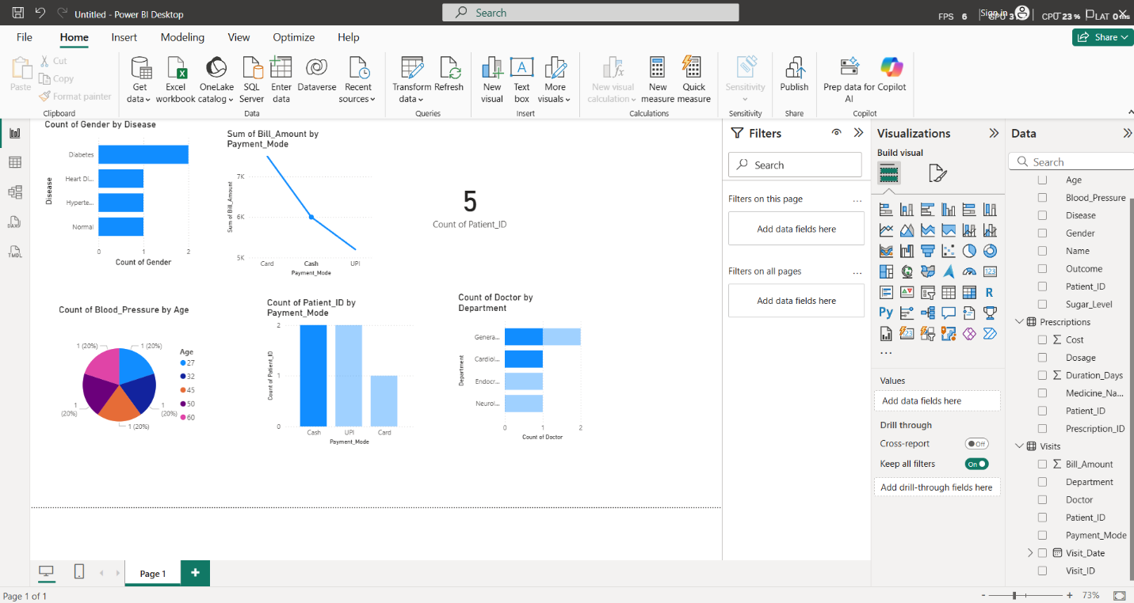

Github Link:  
<https://github.com/JayeshKapade/Jayesh-kapade_ADT23SOCB0483_Assignment_1.git>